INFORMATION SYSTEM CONCEPT
An information system in a general sense is an interconnected set of tools, methods and personnel involved in the implementation of information processes in accordance with the management goal. Information systems are the main technology of information management.
Any management objects: banks, corporations, firms, industrial and economic organizations, government bodies, etc. are complex systems. A system is understood as a set of elements interconnected with each other and with the external environment, the functioning of which is aimed at realizing a specific goal or useful result.
Thus, the organization’s management system can be considered as a complex system that implements a set of measures for its effective functioning. In any system, there are three components: elements of the system; communication elements; purpose of the system.

System features:
the system as a whole performs a certain function, which cannot be reduced to the functions of a single element;
system elements are interconnected and interact within the system; each element of the system can in turn be regarded as an independent system (subsystem), but it performs only part of the functions of the system; subsystems can interact both among themselves and with the external environment and at the same time change their content or internal structure.

Properties of the system:
the complexity of the system depends on the many elements included in it, on their structural interaction, its dynamism, on the complexity of external and internal relations. The power structure management service is characterized by the presence of such tasks where all these qualities are present, for example, the organization of city management, all its subsystems, up to the economic;
the divisibility of the system means that it consists of a number of subsystems, identified by specific signs in accordance with the tasks to be solved and the goals set. For example, these are subsystems of information collection, processing, storage, transmission, analysis;
the integrity of the system implies its functioning, subordinated to a single goal, which makes it possible to achieve its effectiveness. Organization of

effective management of the company - everything is subordinate to this and in accordance with this, tasks and intermediate results are determined;
the variety of elements of the system and the difference in their nature is associated with the functional specificity and autonomy of its elements. For example, for a municipal enterprise management system, such elements are goods, services, prices, labor and material resources.;
the structure of the system determines the presence of established connections and relationships between elements within the system, the distribution of elements horizontally and hierarchy levels.
It should be noted that the structure of any type of economic information is almost identical. The structure is specific information formations endowed with economic meaning. And in such structural units, economic information takes on its real shape. Of course, the structural structure of economic information may be different, but priority is given to the hierarchical principle of distinguishing information formations (units).
There are many definitions of an information system.
Information system - an organizationally ordered set of documents (arrays of documents) and information technologies, including using computer technology and communications that implement information processes.
Information system - a system of information processing in conjunction with the organization’s related resources, such as people, technical and financial resources, which provides and distributes information.
An information system is an interconnected set of tools, methods and personnel used to store, process and issue information in the interests of achieving the goal.
Information system - a complex that includes computing and communication equipment, software, linguistic tools and information resources, as well as system personnel, and providing support for a dynamic information model of some part of the real world to meet the information needs of users.
This definition implies that a certain model of reality already exists (created), the measurement results of which constitute an information resource, and this part of the real world, which is modeled by an information system, is its subject area.
Automated information system (AIS) - a set of information, economic and mathematical methods and models, hardware and software, as well as specialists, designed for computer processing of information and management decisions.
Economic information system - a set of internal and external information flows of an economic object, as well as methods, tools and specialists used in the processes of computer information processing and management decision-making.
An automated information system in management is a system that includes an ordered set of information, economic and mathematical methods and models, hardware and software, as well as personnel and other related resources of

the enterprise, organized on the basis of new information technology and intended for collection, storage, search, processing, analysis, delivery of information at the request of the user, setting and solving managerial problems in order to optimize the management of relevant entities: state, region, city, district, organization, enterprise, company (Fig. 9.1).

The main functions of AIS in management:
collection of information, its input into technical means, primary processing and transmission to the analytical unit;
analysis of the information received and its processing (aggregation, consolidation, derivative calculations, dynamics analysis in the context of various indicators for different periods of time, data interpolation and extrapolation, etc.); generation of managerial decision options, forecasting results and consequences, executing selection algorithms and issuing managerial influences; control over the implementation of decisions made.
Automated information systems solve various problems at different levels of management:
the first (lowest) level of management is the level of performers (operational). Here is the collection, processing and transfer of information (current activity reports) to the next level of management;
the second (middle) level of management is the level of tactical management, which includes coordination of the work of the lower levels, quality control, information transfer to the next level. Here, accounting and analysis of information coming from below (on changes in resources, on fulfilling production tasks, etc.), processing, consolidating and issuing operational reports, that is, regular reports on the results of an object’s activity for certain periods of time, come to the forefront;

Information
Information

Fig. 9.1. Place AIS in the management system
Subject of Management (including management apparatus)
AIS
Information technology
Object (including staff)
Impact of External area
Information about external area

the third (highest) level of management is the level of strategic management, that is, decision-making on planning, reorganization, etc. at the scale of the enterprise as a whole. This kind of management activity requires the use of an arsenal of scientific modeling methods and a quantitative justification of decisions taken, taking into account the structure of the enterprise, available resources and the action of environmental factors.
Management is the transfer of a controlled system from one state to another by means of targeted control action.
Cybernetics, being the science of optimal control of complex dynamic systems, postulates: control is the process of transmitting information. Thus, cybernetics focuses on how something (digital, mechanical or biological) processes information, responds to it and changes or can be changed.
Many dozens of scientific definitions of the term ―management‖ are known, which is the result of applying various approaches: philosophical, political, historical, ideological, legal, economic, socio-psychological, informational, etc. The variety of approaches, in turn, is due to the versatility and complexity of the management phenomenon.
The generally accepted management scheme stands out:
management subject - the one who controls, i.e., generates control commands (signals);

management object - one who is subjected to control actions, i.e., the body that receives control actions from the control subject, receives control commands and acts in accordance with them (Fig. 9.2).

u - control actions X - input parameters Y - output parameters f - disturbing environmental influences
Subject management (system management)
u
Х
Y
Object management
f

Fig. 9.2. Control system diagram

Modern management is carried out taking into account certain indicators, parameters of the object, indicating the state of the object, its behavior and the changes that have occurred. Optimal control is the transfer of a system (object) to a new state with the fulfillment of some criterion of optimality, for example, minimizing the time, labor, substances or energy.
The information channel through which the control subject receives data on the state of the control object, on the perception of control commands by it, on the results of control, is defined as a feedback channel. In this case, they talk about a feedback control system (Fig. 9.3).

Subject management g (system management)

u

Х Y
Object management

f

u – controllable impact X – input parameters Y – output parameters
- – indigant impacts of external environment
- – planning indicators of object

Fig. 9.3. Feedback control system diagram

In this case, the control subject establishes a set of indicators for the control object, their desired (target) values, as well as the methods and frequency of measuring these parameters. Thus, in the ―representation‖ of the control system, an information-parametric model of the future state of the object, that is, what it should become as a result of control, arises.
The totality of data on the actual and possible state of the controls and the external conditions for the functioning of the process, as well as the logic for changing and transforming the controls is called information support. Thus, information support is part of the management system.
From the perspective of information management, management looks like a cyclical information process (Fig. 9.4).
There are various approaches to the scientific definition of common management functions. The following are widely recognized in science and practice:
coordination, integration and control (F. Taylor);
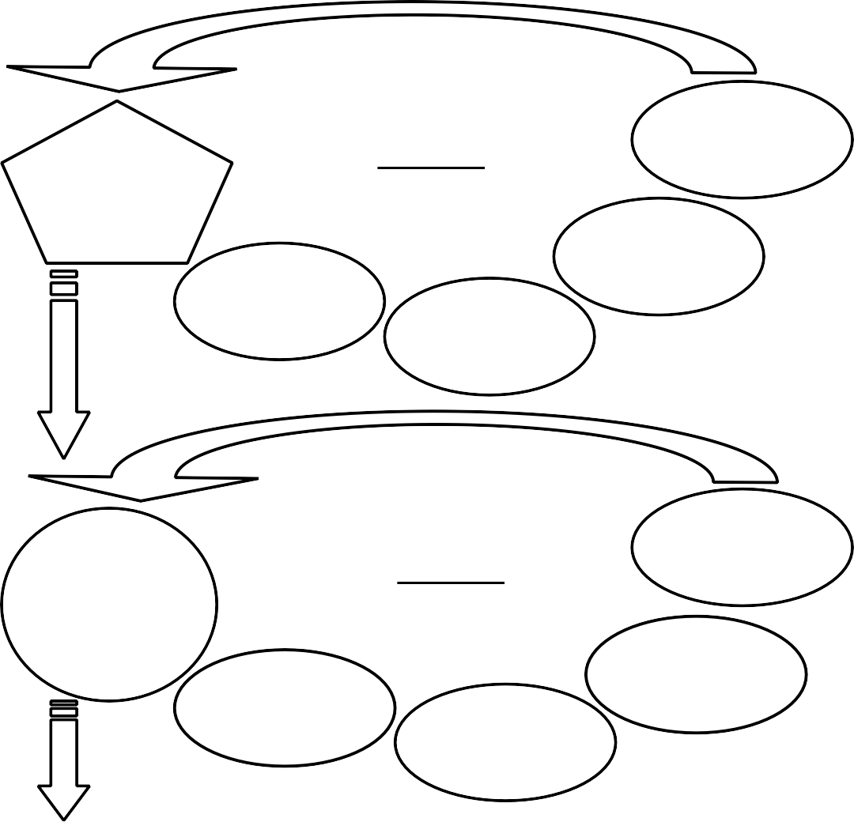
development of goals and strategies, coordination, operational management (T. Parsons);
6: Management Impact
1: Object management
CYCLE 1
5: Making management and solution
2: Data grabbing (object)
4: New data about
3:Data analysis
7
13: Management influence (correction)
8: New object
management
CYCLE 2
12: Making management and solution
14
9: Data grabbing (objects)
11: New data of object
10: Data analysis
…
Fig. 9.4. Information Management

planning, organization, motivation, control, coordination (A. Fayol); goal setting, goal achievement, analysis, motivation, decision making (P. Drucker);
planning, organization, execution, control (Robert M. Falmer); planning, organization, leadership, motivation, control (K. Killen);
planning, organization, staffing, leadership and leadership (G. Kunz, S. O'Donnell);
organization, planning, regulation, staffing, control (G.V. Atamanchuk); forecasting and planning, organization of work, motivation, coordination and regulation, control, accounting and analysis;
information collection, analysis, forecasting, planning, motivation, organization, operational management, control, accounting, distribution (V.K. Goncharuk) and etc.
Summarizing the above views, all the above management functions can be reduced to four main functions:
- planning (including the development of goals and strategies, goal-setting and goal-achievement, strategic planning and forecasting);
- organization (including the creation of an organizational structure, staffing and the formation of other types of resources, as well as the development of regulations, rules, incentive systems, etc. for solving future tasks);
- regulation (including operational management, coordination, integration, leadership, leadership, decision making);
- control (including monitoring, analysis, audit).
These functions form a connected sequence in the control process, i.e., are its stages (Fig. 9.5).
1: Planning -
2: Organi - zation
3: Regu lation
-
4: Control

Fig. 9.5. Stages (functions) of process management

At the same time, the results of the fourth stage of management will be input to the first stage of a new cycle of the management process - planning, taking into account data about the changed management object. Thus, the common control functions form a universal cyclic sequence of stages of the control process.
Of course, all management processes take place in the information field, in an inextricable connection and interaction with information processes. Information management as an activity combines management processes and information processes and is implemented in this field of process interactions on the principle of "each with each" in the form of its technologies (Fig. 9.6).

In process of management
In technologies of informational management
In informational processes
Realization of informational management

Planning
Data searching
Organization
Data storing
Regulation
Data handling
Control
Data transmission

Fig. 9.6. Information Management Implementations

Thus, if the information manager is engaged in planning, then for this he must carry out information processes: search, storage, processing and transmission of relevant planning information. On the other hand, if, for example, he is faced with the task of preserving information, then for its solution it is necessary to carry out management processes: planning, organization, regulation and control of information storage.

Information System and Information Technology.
Information technology (IT) in the general sense arose when people began to maintain and transmit their knowledge and skills to future generations, that is, to search, store, process and transmit information. The advent of computers increased the effectiveness of these processes, which made it possible to use computer technology in economics and management. Information technology is essentially a means and processes of operating information. Therefore, the following definition of information technology will be fair.
Information technology in the broadest sense is a system of organizing for solving management problems a set of methods and means of implementing the operations of collecting, registering, transmitting, accumulating, searching, processing and protecting information (including through the use of developed software), used computer equipment and communication, as well as the ways in which information is offered to the user-manager.
In this sense, the information system (IS) is the most important information technology, since it is an indispensable tool for processing information in almost all areas of human activity.
On the other hand, an information system is a medium for information technologies in the narrow sense, since it always contains information technologies

for searching, storing, processing and transmitting information using software and hardware. In the narrow sense, information technology, on the contrary, can exist outside the information system.
In contrast to information technology, the information system contains not only information itself, information technologies, computer equipment, but also other various types of organization resources tied to it, primarily human resources,
i.e. personnel.
Thus, the modern automated information system (AIS) is a human-machine information processing system using computer information technologies. Each management system has its own information system.

