SIW

1. Robot vacuum cleaner

On the basis of Arduino, you can create a useful thing for the house-a robot cleaner. A self-made model will not be inferior in its characteristics to a store copy.

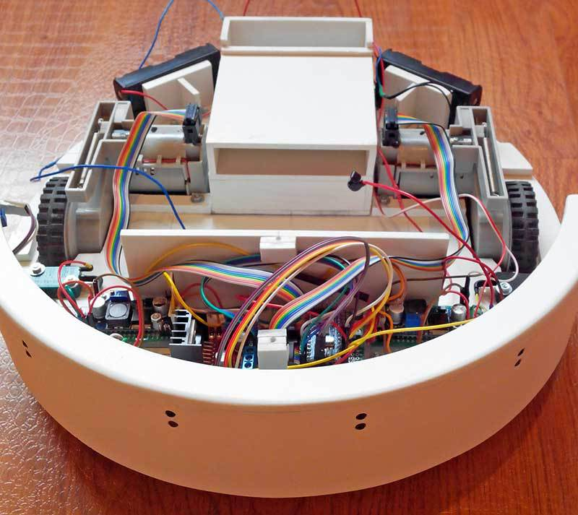

Figure 80. Robot vacuum cleaner

To build, you will need:
Arduino;
- L298N driver for engine management;
- miniature motors with gear and wheels;
- infrared sensors;
- the engine for the turbine;
- turbine;
- brush motors;
- collision sensors;
- 4 batteries;
- step-up and step-down current converters;
- controller for the battery.
The vacuum cleaner is equipped with IR sensors. They react when the vacuum cleaner approaches an obstacle and give it the command to stop and turn around. When a collision with a wall or other obstacle triggers one of the switches connecting the bumper and the robot body.

2. Face recognition and tracking system on Arduino

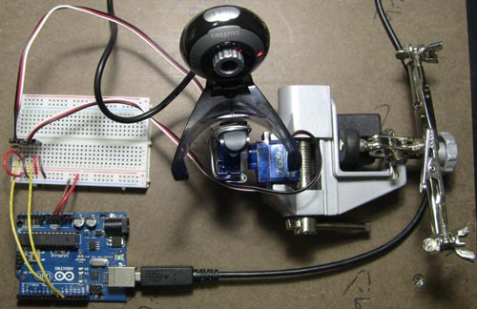

Figure 81. Face recognition and tracking system

The webcam is mounted on a swivel mechanism and connected to a PC that has the OpenCV software installed. When the program detects a face, its center point is calculated. The received coordinates are transmitted to the Arduino microcontroller, which controls the servomotors and monitors the face. Will be required for implementation:
- Arduino IDE, OpenCV software;
- Arduino UNO Board;
- 2 servomotors;
- the web camera.
3. Automated system for aquarium

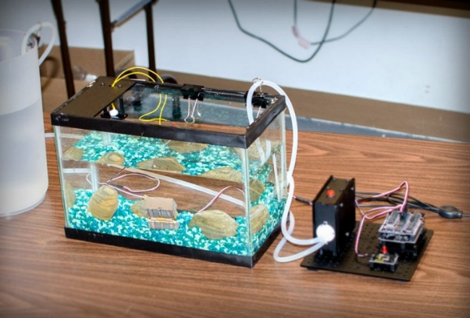

Figure 82. Aquarium's

Automating tasks for the aquarium helps make life easier for the user. The project should be responsible for the following actions:
- lighting of a particular color depending on the conditions;
- time display;
- regulation of the compressor;
- enabling and disabling filters;
- display of temperature and humidity data.
To assemble the device, you will need an Arduino UNO Board, piezo signal, RGB tape, white diode tape, temperature and humidity sensor, LCD screen, clock, 2 relays, IR receiver, transistors.
There are many schemes for implementing the device. An example of one of them is given below.
You also need to write a code to enable a particular color depending on the conditions and adjust the operation of the LCD screen.

4. Greenhouse for plants

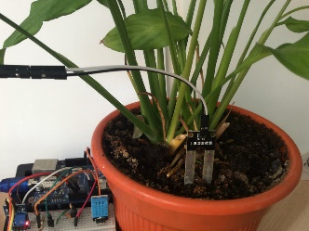
Figure 83. Greenhouse for plants

In the smart greenhouse for flowers, the temperature and lighting are monitored and adjusted, and the soil is watered. This is especially true for heat-loving tropical plants, which need to constantly maintain a high temperature. You can control it automatically or remotely from your tablet or smartphone.
To build a project, you need the following components:

Arduino UNO;

USB cable;

prototyping Board;

wires;

photoresistor;

10kOhm resistor;

temperature sensor;

ambient temperature and humidity module;

soil moisture modulus.

The photoresistor is responsible for measuring illumination. The temperature sensor receives the temperature of the air. The soil moisture module is placed in the ground and measures the water level in it.

