**Lecture 12**

**Selecting a Sample Meaning and Definition of Sampling.**

**What is sampling?**

Sampling is a technique of selecting individual members or a subset of the population to make statistical inferences from them and estimate the characteristics of the whole population. Different sampling methods are widely used by researchers in market research so that they do not need to research the entire population to collect actionable insights.

It is also a time-convenient and a cost-effective method and hence forms the basis of any research design. Sampling techniques can be used in a research survey software for optimum derivation.

For example, if a drug manufacturer would like to research the adverse side effects of a drug on the country’s population, it is almost impossible to conduct a research study that involves everyone. In this case, the researcher decides a sample of people from each demographic and then researches them, giving him/her indicative feedback on the drug’s behavior.

**Types of sampling: sampling methods**

Sampling in market action research is of two types – probability sampling and non-probability sampling. Let’s take a closer look at these two methods of sampling.

Probability sampling: Probability sampling is a sampling technique where a researcher sets a selection of a few criteria and chooses members of a population randomly. All the members have an equal opportunity to be a part of the sample with this selection parameter.

Non-probability sampling: In non-probability sampling, the researcher chooses members for research at random. This sampling method is not a fixed or predefined selection process. This makes it difficult for all elements of a population to have equal opportunities to be included in a sample.

In this blog, we discuss the various probability and non-probability sampling methods that you can implement in any market research study.

**Types of probability sampling with examples:**

Probability sampling is a sampling technique in which researchers choose samples from a larger population using a method based on the theory of probability. This sampling method considers every member of the population and forms samples based on a fixed process.

For example, in a population of 1000 members, every member will have a 1/1000 chance of being selected to be a part of a sample. Probability sampling eliminates sampling bias in the population and gives all members a fair chance to be included in the sample.

There are four types of probability sampling techniques:

Simple random sampling: One of the best probability sampling techniques that helps in saving time and resources, is the Simple Random Sampling method. It is a reliable method of obtaining information where every single member of a population is chosen randomly, merely by chance. Each individual has the same probability of being chosen to be a part of a sample.

For example, in an organization of 500 employees, if the HR team decides on conducting team building activities, it is highly likely that they would prefer picking chits out of a bowl. In this case, each of the 500 employees has an equal opportunity of being selected.

Cluster sampling: Cluster sampling is a method where the researchers divide the entire population into sections or clusters that represent a population. Clusters are identified and included in a sample based on demographic parameters like age, sex, location, etc. This makes it very simple for a survey creator to derive effective inference from the feedback.

For example, if the United States government wishes to evaluate the number of immigrants living in the Mainland US, they can divide it into clusters based on states such as California, Texas, Florida, Massachusetts, Colorado, Hawaii, etc. This way of conducting a survey will be more effective as the results will be organized into states and provide insightful immigration data.

Systematic sampling: Researchers use the systematic sampling method to choose the sample members of a population at regular intervals. It requires the selection of a starting point for the sample and sample size that can be repeated at regular intervals. This type of sampling method has a predefined range, and hence this sampling technique is the least time-consuming.

For example, a researcher intends to collect a systematic sample of 500 people in a population of 5000. He/she numbers each element of the population from 1-5000 and will choose every 10th individual to be a part of the sample (Total population/ Sample Size = 5000/500 = 10).

Stratified random sampling: Stratified random sampling is a method in which the researcher divides the population into smaller groups that don’t overlap but represent the entire population. While sampling, these groups can be organized and then draw a sample from each group separately.

For example, a researcher looking to analyze the characteristics of people belonging to different annual income divisions will create strata (groups) according to the annual family income. Eg – less than $20,000, $21,000 – $30,000, $31,000 to $40,000, $41,000 to $50,000, etc. By doing this, the researcher concludes the characteristics of people belonging to different income groups. Marketers can analyze which income groups to target and which ones to eliminate to create a roadmap that would bear fruitful results.

Uses of probability sampling

There are multiple uses of probability sampling:

Reduce Sample Bias: Using the probability sampling method, the bias in the sample derived from a population is negligible to non-existent. The selection of the sample mainly depicts the understanding and the inference of the researcher. Probability sampling leads to higher quality data collection as the sample appropriately represents the population.

Diverse Population: When the population is vast and diverse, it is essential to have adequate representation so that the data is not skewed towards one demographic. For example, if Square would like to understand the people that could make their point-of-sale devices, a survey conducted from a sample of people across the US from different industries and socio-economic backgrounds helps.

Create an Accurate Sample: Probability sampling helps the researchers plan and create an accurate sample. This helps to obtain well-defined data.

Types of non-probability sampling with examples

The non-probability method is a sampling method that involves a collection of feedback based on a researcher or statistician’s sample selection capabilities and not on a fixed selection process. In most situations, the output of a survey conducted with a non-probable sample leads to skewed results, which may not represent the desired target population. But, there are situations such as the preliminary stages of research or cost constraints for conducting research, where non-probability sampling will be much more useful than the other type.

Four types of non-probability sampling explain the purpose of this sampling method in a better manner:

**Convenience sampling:** This method is dependent on the ease of access to subjects such as surveying customers at a mall or passers-by on a busy street. It is usually termed as convenience sampling, because of the researcher’s ease of carrying it out and getting in touch with the subjects. Researchers have nearly no authority to select the sample elements, and it’s purely done based on proximity and not representativeness. This non-probability sampling method is used when there are time and cost limitations in collecting feedback. In situations where there are resource limitations such as the initial stages of research, convenience sampling is used.

For example, startups and NGOs usually conduct convenience sampling at a mall to distribute leaflets of upcoming events or promotion of a cause – they do that by standing at the mall entrance and giving out pamphlets randomly.

**Judgmental or purposive sampling:** Judgemental or purposive samples are formed by the discretion of the researcher. Researchers purely consider the purpose of the study, along with the understanding of the target audience. For instance, when researchers want to understand the thought process of people interested in studying for their master’s degree. The selection criteria will be: “Are you interested in doing your masters in …?” and those who respond with a “No” are excluded from the sample.

**Snowball sampling:** Snowball sampling is a sampling method that researchers apply when the subjects are difficult to trace. For example, it will be extremely challenging to survey shelterless people or illegal immigrants. In such cases, using the snowball theory, researchers can track a few categories to interview and derive results. Researchers also implement this sampling method in situations where the topic is highly sensitive and not openly discussed—for example, surveys to gather information about HIV Aids. Not many victims will readily respond to the questions. Still, researchers can contact people they might know or volunteers associated with the cause to get in touch with the victims and collect information.

**Quota sampling:** In Quota sampling, the selection of members in this sampling technique happens based on a pre-set standard. In this case, as a sample is formed based on specific attributes, the created sample will have the same qualities found in the total population. It is a rapid method of collecting samples.

**Uses of non-probability sampling**

Non-probability sampling is used for the following:

Create a hypothesis: Researchers use the non-probability sampling method to create an assumption when limited to no prior information is available. This method helps with the immediate return of data and builds a base for further research.

Exploratory research: Researchers use this sampling technique widely when conducting qualitative research, pilot studies, or exploratory research.

Budget and time constraints: The non-probability method when there are budget and time constraints, and some preliminary data must be collected. Since the survey design is not rigid, it is easier to pick respondents at random and have them take the survey or questionnaire.

How do you decide on the type of sampling to use?

For any research, it is essential to choose a sampling method accurately to meet the goals of your study. The effectiveness of your sampling relies on various factors. Here are some steps expert researchers follow to decide the best sampling method.

Jot down the research goals. Generally, it must be a combination of cost, precision, or accuracy.

Identify the effective sampling techniques that might potentially achieve the research goals.

Test each of these methods and examine whether they help in achieving your goal.

Select the method that works best for the research.

Difference between probability sampling and non-probability sampling methods

We have looked at the different types of sampling methods above and their subtypes. To encapsulate the whole discussion, though, the significant differences between probability sampling methods and non-probability sampling methods are as below:

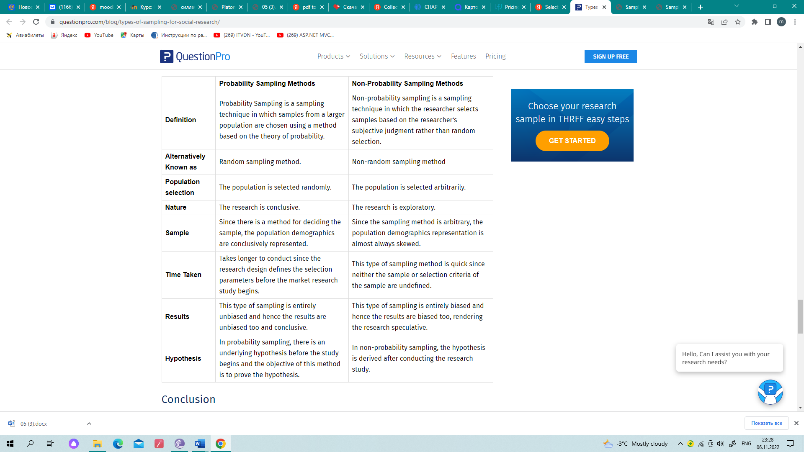Now that we have learned how different sampling methods work and are widely used by researchers in market research so that they don’t need to research the entire population to collect actionable insights let’s go over a tool that can help you manage these insights.

QuestionPro understands the need for an accurate, timely, and cost-effective method to select the proper sample; that’s why we bring QuestionPro Software, a set of tools that allow you to efficiently select your target audience, manage your insights in an organized, customizable repository and community management for post-survey feedback.

**Resources for Further Reading**

Barbour RS. Making sense of focus groups. Med Educ. 2005;39(7):742–750.

Britten N. Qualitative interviews in medical research. BMJ. 1995;311(6999):251–253.

Denzin NK, Lincoln YS. Collecting and Interpreting Qualitative Materials. 3rd ed. London, England: Sage; 2008.

Dicicco-Bloom B, Crabtree BF. The qualitative research interview. Med Educ. 2006;40(4):314–321.

Freeman T. “Best practice” in focus group research: making sense of different views. J Adv Nurs. 2006;56(5):491–497.

Green J, Thorogood N. Qualitative Research Methods for Health Research. 3rd ed. London, England: Sage; 2014.

Hodges BD, Kuper A, Reeves S. Discourse analysis. BMJ. 2008;37:a879:570–572.

Hsieh HF, Shannon SE. Three approaches to qualitative content analysis. Qual Health Res. 2005;15(9):1277–1288.

O’Leary Z. Researching Real-World Problems: A Guide to Methods of Inquiry. London, England: Sage; 2005.

Park S, Griffin A, Gill D. Working with words: exploring textual analysis in medical education research. Med Educ. 2012;46(4):372–380.

Mays N, Pope C. Qualitative research: observational methods in health care settings. BMJ. 1995;311(6998):182-184.

Reeves S, Peller J, Goldman J, Kitto S. Ethnography in qualitative educational research: AMEE guide No. 80. Med Teach. 2013;35(8):e1365–1379.